Pick Your Package ***All Packages must be Get a discount if signed up paid in full by Feb 28
before Feb 15th, 2022 2022 in order to receive
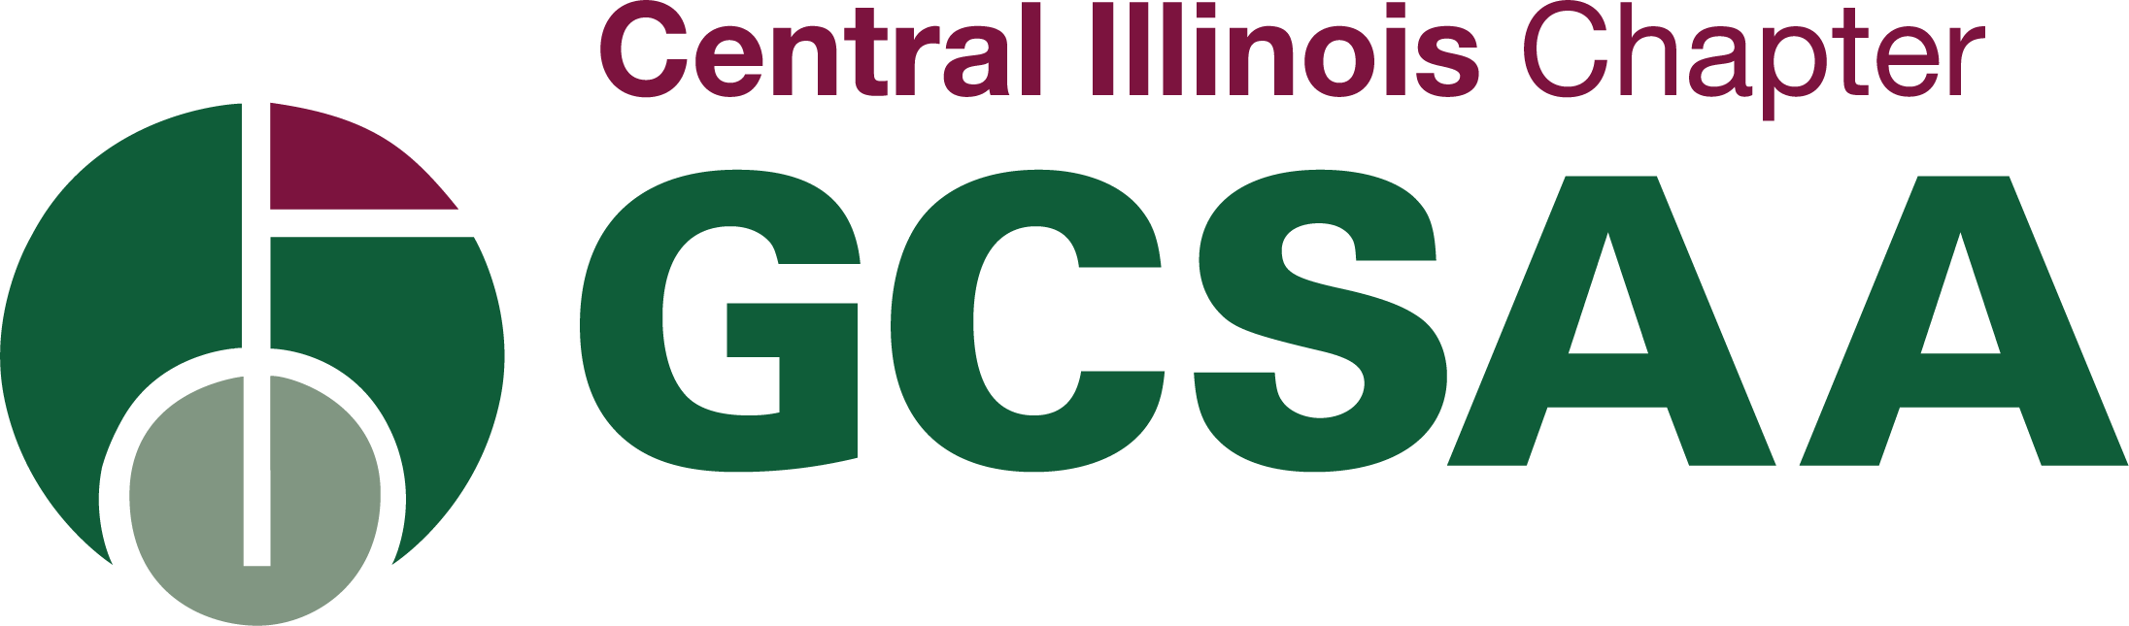
& paid by Feb 28, 2022 the discounted price!
Partner Recognition Program

Vendor Name: _____________________________
Sponsorship Package: __________________________

2022 Sponsorship Packages | Elite ($3000) | Diamond ($2500) | Platinum ($2000) | Gold ($1500) | Silver ($1000) | Bronze ($500)
Associate Membership | 4* | 3* | 2* | 2* | 1* | 1*
Title Sponsor for Memorial Matchplay Championship | ✓
Event Sponsorship (You Pick your Events) | 7 | 5 | 4 | 3 | 2
Proximity Sponsor (Vendor Day Event $50) | 1 | 1 | 1 | 1 | 1 | 1
Proximity Sponsor (Chapter Champship Event $50) | 1 | 1 | 1
Proximity Sponsor for 9 Hole Event $50 | 1 | 1
Tee sign at Vendor Day | ✓ | ✓ | ✓ | ✓ | ✓ | ✓
Tee sign at all golf events (except Scholarship Fundraiser and Memorial Matchplay) | ✓ | ✓ | ✓ | ✓ | ✓
Recognition on website | ✓ | ✓ | ✓ | ✓ | ✓ | ✓
Ad in directory | Full page | Full page | 1/2 page | 1/4 page | 1/4 page | 1/8 page
Recognition/Sponsor Tweets per year | 12 | 12 | 6 | 4 | 3 | 2
• One (1) free attendance to each event you sponsor (except Scholarship Fundraiser) | ✓ | ✓ | ✓ | ✓ | ✓
Sponsor to bring other members at no additional charge to events they sponsor (except Scholarship Fundraiser) | up to 3 | up to 2 | 1 | 1 | 1
Name & Logo on banner at check-in table | ✓ | ✓ | ✓ | ✓ | ✓
Name on banner at check-in table only |  |  |  |  |  | ✓
One free attendance to the annual meeting | ✓ | ✓ | ✓ | ✓ | ✓ | ✓
Free CIGCSA apparel | ✓ | ✓
Discount for paying before (Feb 28th) | 10% | 5% | 5% | 5% | 5% | 5%
*If your company needs more Associate Memberships, please contact the chapter manager to ask about discounted prices
Pick Your Package ***All Packages must be Get a discount if signed up paid in full by Feb 28th
before Feb 15th, 2022 in order to receive
& paid by Feb 28th 2022 the discounted price!

Sponsorship Packages
Elite Sponsorship- $3,000 ($2700 with 10% Discount)
Includes:
- Up to 4 Associate Members from your company
- Company Sponsorship all events (excluding Scholarship Fundraiser and Memorial Matchplay Championship) allows you to bring up to 3 members of the association at no additional charge, one free attendee
- Name and Logo on CIGCSA Banner
- Full page ad in the directory
- Title sponsor for Memorial Matchplay Championship
- Company Name and Logo on CIGCSA website and link to your home page
- 1 proximity sponsors at Vendor Day, Chapter Championship, and 9-hole event
- Tee sign at all golf events (excluding Scholarship Fundraiser and Memorial Matchplay Championship
- 12 Recognition/Sponsor Tweets per year
- Free CIGCSA apparel
- A Total value of $4,980 for a value of $3,000

Diamond Sponsorship-$2,500 ($2,375 with 5% Discount)
Includes:
- Up to 3 Associate Members from your company
- Company Sponsorship 5 events (excluding Scholarship Fundraiser and Memorial Matchplay Championship) allows you to bring up to 2 members of the association at no additional charge, one free attendee
- Name and Logo on CIGCSA Banner
- Full page ad in the directory
- Company Name and Logo on CIGCSA website and link to your home page
- 1 Proximity Sponsor at Vendor Day, Chapter Championship, and 9-Hole event
- Tee sign at all golf events (excluding Scholarship Fundraiser and Memorial Matchplay Championship
- 12 Recognition/Sponsor Tweets per year
- Free CIGCSA apparel
- A Total value of $3,830 for a value of $2,500

Platinum Sponsorship-$2,000 ($1,900 with 5% Discount)
Includes:
- Up to 2 Associate Members from your company
- Company Sponsorship 4 events (excluding Scholarship Fundraiser and Memorial Matchplay Championship) allows you to bring 1 member of the association at no additional charge, one free attendee
- Name and Logo on CIGCSA Banner
- Half page ad in the directory
- Company Name and Logo on CIGCSA website and link to your home page
- 1 Proximity Sponsor at Vendor Day, Chapter Championship
- Tee sign at all golf events (excluding Scholarship Fundraiser and Memorial Matchplay Championship
- 6 Recognition/Sponsor Tweets per year
- Free CIGCSA apparel
- A Total value of $2,915 for a value of $2,000

Gold Sponsorship-$1,500 ($1,425 with 5% Discount)
Includes:
- Up to 1 Associate Members from your company
- Company Sponsorship 3 events (excluding Scholarship Fundraiser and Memorial Matchplay Championship) allows you to bring 1 member of the association at no additional charge, one free attendee
- Name and Logo on CIGCSA banner
- Quarter page ad in the directory
- Company Name and Logo on CIGCSA website and link to your home page
- 1 Proximity Sponsor at Vendor Day
- Tee sign at all golf events (excluding Scholarship Fundraiser and Memorial Matchplay Championship
- 4 Recognition/Sponsor Tweets per year
- A Total value of $2,108.25 for a value of $1,500

Silver Sponsorship-$1,000 ($950 with 5% Discount)
Includes:
- Up to 1 Associate Member from your company a ($150 value)
- Company Sponsorship 2 events (excluding Scholarship Fundraiser and Memorial Matchplay Championship) allows you to bring 1 member of the association at no additional charge, one free attendee
- Name and Logo on CIGCSA Banner
- Quarter page ad in the directory
- Company Name and Logo on CIGCSA website and link to your home page
- 1 Proximity Sponsor at Vendor Day
- Tee sign at all golf events (excluding Scholarship Fundraiser and Memorial Matchplay Championship
- 3 Recognition/Sponsor Tweets per year
- A Total value of $1832.50 for a value of $1,000

Bronze Sponsorship-$500 ($475 with 5% Discount)
Includes:
- Up to 1 Associate Members form your company
- One free attendance to the annual meeting or Shop Meeting
- Name on CIGSA Banner
- Business card ad in the directory
- Company Name and Logo on CIGCSA website and link to your home page
- 1 Proximity Sponsor at Vendor Day
- Tee sign at Vendor Day
- 2 Recognition/Sponsor Tweets per year
- A Total value of $655 for a value of $500

2022 Misc. Sponsorship/Advertising Options- $ Variable
- Associate Membership (Membership @ $150) ____ X ______ = ________
- Proximity Sponsor ($50) ____ X _____ = ________
- Vendor Day Tee Sponsorship ($250 per tee) ____ X _____ = ________
- Research Donation benefitting the George “Tony” Polillo Turfgrass Research Fund ________

Total = _______
Payment is due 4/1/2022*

*Partners can make more flexible payments and arrangements with Chapter Manager.

Pick Your Package ***All packages must be
Get a discount if signed up paid in full by Feb 28
before Feb 15th, 2022 2022 in order to receive
and paid by Feb 28, 2022 the discount!

Company Name__________________________________________________________
Company Address ________________________________________________________
City _______________________________________State_______ Zip____________
Contact Name________________________________ Job Title______________________
Phone # ____________________________ Email Address__________________________

Please indicate hyperlink for the website:_________________________________________
Please indicate your companies twitter handle: ____________________________________
Please choose the number of events that correspond with your package:
  - March: Shop Meeting ____
  - June: Vendor Day ___
  - July: Chapter Championship___
  - Aug: 9 Hole Event ___
  - Dec: Annual Meeting____
  - Jan: Winter Social ___
  - Feb: GIS _____
Names and twitter handles for Associate Membership:

Sponsorship Level (please circle)
Elite ($3000) Diamond ($2500) Platinum ($2000) Gold ($1500) Silver ($1000) Bronze ($500)

Payment Method (Please Circle)
Check Enclosed Send Me an Invoice

Please make checks payable to: CENTRAL ILLINOIS GOLF COURSE SUPERINTENDENTS ASSOCIATION
P.O BOX 3684 BLOOMINGTON, IL 61702-3684 OR EMAIL TO CI-GCSA@HOTMAIL.COM

